**From control using with and without spread operator**

Without spread operator:

import React, { useState } from 'react'

Here we don’t use object in the useState

export default function Form_controller() {

  const [name, setname] = useState("");

  const [email, setemail] = useState("");

  const [password, setpassword] = useState("");

let handleName=(e)=>{

    setname(e.target.value)

And here we create multiple function to set the value

}

let handleEmail=(e)=>{

    setemail(e.target.value)

}

let handlePassword=(e)=>{

    setpassword(e.target.value)

}

let handleSubmit=(e)=>{

    console.log({name,email,password})

    e.preventDefault()

}

  return (

    <div>

      <hr />

      <h2>Form Control</h2>

      <form action="" onSubmit={handleSubmit}>

        <label htmlFor="name">Name:</label>

        <input onChange={handleName} id='name' type="text" />

        <br /><br />

        <label htmlFor="email">Email:</label>

        <input id='email' type="email" onChange={handleEmail} />

        <br /><br />

        <label htmlFor="password">Password:</label>

        <input id='password' type="password" onChange={handlePassword} />

        <br /><br />

        <button type="submit" > Submit</button>

      </form>

    </div>

  )

}

With spread operator:

Here we use object in the useState to declare the name and value. And here we declare three name

import React, {useState} from 'react'

export default function Form_using_sprade_operator() {

    const [user, setuser] = useState({name:"",email:"", password:""});

Distructuring of the object

    let {name,email,password}=user

    let handlechange=(e)=>{

Here we use spread operator to spread the user in the useState to declare the name and store the value of the name

        setuser({...user,[e.target.name]:e.target.value})

    }

    let handleSubmit=(e)=>{

            console.log(user)

            e.preventDefault()

    }

And here we use just one function for all the input section

  return (

    <div>

Use preventDefault to show the result in the console

        <br />

        <hr />

        <h3>Form control using spread operator </h3>

Here we must set the value and name of the input section

        <br />

        <form action="" onSubmit={handleSubmit}>

            <label htmlFor="name">Name:</label>

    <input onChange={handlechange} type="text" id='name' value={name} name="name"  />

            <br /><br />

            <label htmlFor="email">Email:</label>

     <input onChange={handlechange} type="text" id='email' value={email} name="email"  />

            <br /><br />

            <label htmlFor="password">Password:</label>

   <input onChange={handlechange} type="text" id='password' value={password} name="password"  />

            <br /><br />

            <button type="submit">Submit</button>

        </form>

    </div>

  )

}

After putting the code

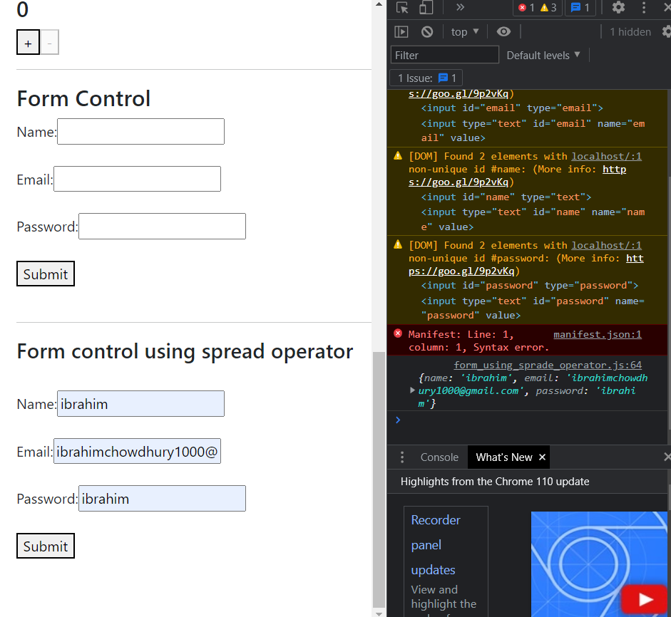

After submitting the form we can see the result